Influence Speed Maximization in Social Networks

# ABSTRACT

Influence maximization in social networks is a problem of how to find a given sized seed node, such that the influence of the initial nodes can reach as many as possible of other nodes in social networks. Carefully studying of previous works reveal that most of them are focusing in the problem which I called space maximization, i.e. how to start from initial seed nodes to reach a maximum number of final being affected nodes, few of them considering time constrains.

In this paper, I will study a different but also important problem, influence speed maximization in social networks. In introduction section, we will see why this is a meaningful work. Because the similarity between space maximization and speed maximization in social networks, the study of precious works in space maximization can be a good start point and solid foundation for my work. I will extend the classic IC model to CDE (Continuous Dynamic Extensional) IC model, which will better reflect the properties of social networks. During the seed selection phase, I will try random selection and two most famous heuristic algorithms: degree-centered and distance-centered algorithms. Finally, I will propose a degree discount algorithm. The result will show that even a small change to the heuristic algorithm can greatly improves the influence speed in social networks. In propagation phase, how to decide the probability is also a huge topic. I will try to solve it with different methods.

# INTRODUCATION

Social networks, e.g. Facebook, Twitter, LinkedIn and Instagram, although having different functionalities, all of them, connect people together based on relationships, like friends, families, and followers, and provide platforms for connected people sharing information, new technologies and views on new products. For the vast spread scope and explosive speed, social networks are deemed as ideal marketing platform. For the limitation of budget, one challenge is that how to find an initial influential seed nodes that we can maximize the influence in social networks. Based on the study of previous work, I found that most of them are focusing how to maximize number of the affected nodes, which I called space maximization problem. One important constrains that they ignored is time. So, a different and related problem, i.e. how to find an initial seed nodes such that the number of being affected nodes in unit time is maximal, is named as influence speed maximization in social networks. Before I show the meaning of influence speed maximization problem, let’s look at a simple example from Figure 1 and Figure 2.

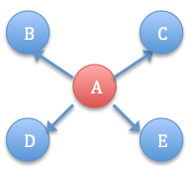 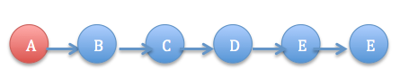

Figure 1 Figure 2

Suppose Figure 1 and Figure 2 are two subnets in a social network. Node A is selected as seed node, which means it is affected. Node A will make sure propagate the influence to all the nodes in its path (directly or indirectly connected to node A). So, which node A should we choose? Clearly, from space maximization point of view, node A in Figure2 is a better candidate for it can propagate its influence to five other nodes comparing to node A in Figure 1, which can only affect four other nodes, one less than node A in Figure 2. But, in the speed maximization point of view, node A in Figure 1 should be a better choice, since its influence can reach to more other nodes in unit time, if the influence can only propagate one step per unit time in social networks.

In real businesses, the budget is limited for all kinds of reasons. They can only select small size seed nodes to propagate the influence to the whole social networks. But, they always want a fast rate of ROI (Return of Investment). On one hand, they are pursuing a more healthy cash flow, one the other hand, no one product will dominate the market forever. Information will be out-of-date. Traditional technologies will be replaced by new one. Since everything (news, idea, technology) has its expire time, how to create a hotspot in short time, that is a speed maximization problem. Speed maximization problem is different to space maximization problem. But they also have similarity for they both study the properties of social networks and try to model social networks more precisely and more predictable. So, the study of space maximization problem can be helpful to speed maximization problem, and will provide a solid foundation to speed maximization problem.

Domingos and Richardson 1,2 are the first one to study influence maximization problem in virtual marketing. Instead of viewing a market as independent individualities and considering intrinsic value of a customer only, they model a social network as a Markov random field and make decision based on customer’s network value, which is an expected profit can get from all the other customers who are influenced by this customer directly or indirectly. However, Kempe, Kleinberg and Tardos 3 provide foundation for influence maximization problem. They proved the optimization problem of selecting the most influence nodes is NP-hard, and they also gave the first provable approximation solution to that problem, which is within 63% (1- 1/e) of optimal for both IC (Independent Cascade) model and LT (Linear Threshold) model. Social networks are modeled as a graph, where nodes represent individuality and edges means all kinds of relationships (friends, family or followers) between people. Influence maximization problem can be described as how to start from seed nodes of size k, influence will propagate to the other nodes with some probability and get a maximized total number of N nodes. They used a greedy algorithm, which is called hill-climbing algorithm to get their solution. However, efficiency is big drawback in their algorithm. Trying to calculate influence of a given seed nodes set proves to be a difficult task. Instead of get the precise value, they run Monte-Carlo simulations on their models so many times to get an accurate estimation. But, even to find a small seed nodes set in a moderately large network (e.g. 15000 nodes) would take days to finish.

Based on Kempe et al. work, a lot of following works have been done trying to improve the efficiency of seed picking phase. In 4, Leskovec, Krause and Guestrin propose a general method near optimal, which is called CELF (Cost Effective Lazy Forward) scheme, by exploiting the submodularity property of influence maximization, they greatly reduce the number of nodes needed to consider in each step of seed nodes picking phase. Their algorithm scales well to large problem and experiments show that it is 700 times faster than a simple greedy algorithm. Further work is done by Goyal, Lu and Lakshmanan in 5. , In their paper, they propose an algorithm called CELF++, which is 35%-55% faster than CELF.

Chen, Wang and Yang 6 try to tackle the efficiency issue of influence maximization from a different direction. Instead of trying to further reducing running time of greedy algorithm, they improve heuristics method. Their experiments show that they can a nearly match result comparing with greedy algorithm. And, the new heuristics significantly reduce running time, which is more than six orders magnitude faster than any existing greedy algorithms.

# RELATED WORK

In this section, I will introduce related works about influence propagation models and some algorithms for seed selection.

## MODLES

Let G be a directed graph represents a social network, V is the nodes set, each v in V represents individuality in social networks, and E is the edges set represent relationships between individualities. Influence maximization problem is how to pick an optimal initial seed nodes set from V, so that their influence can reach the maximum other nodes in social network. The spread process of ideas or innovation is dynamic. We need a good model to match more closely to real social networks. Before my study, there should be some constrains on the model. First, the state change of nodes is one-way. During each step, every node is either active, which means it is under influence, or inactive, which is not be affected yet. But, once node changes its state from inactive to active, there is no way it can reverse the process, which is from active state to inactive state. Second, each inactive node’s tendency to become active increases monotonically. When there are more neighbors of an inactive node becoming active, the probability of this inactive node should also increase. Under these assumptions, the propagation progress of influence can be like that, starting from an initial active seed nodes, each active node tries to influent its neighbors. When more and more the neighbors of an inactive node become active, this inactive node can also become active, and tries to propagate the influence to its neighbors, until there is no way to propagate to any nodes.

### Linear Threshold Model

Granovetter and Schelling 7,8 are among the first ones trying to propose a model. Their method is based on node-specific threshold. Many similar models are proposed based on this idea. But, Linear Threshold Model is the most important.

In this model, each inactive node v is influenced by its neighbor nodes set W. For each node w belong to nodes set W, it has an influence weight bu, w. The total weights of its neighbors will satisfy a condition, which is ∑ bu, w ≤ 1 (for all nodes in nodes set W). Then process of influence propagate in social network with Linear Threshold model is like this, each node v has an initial threshold θv, which is chosen uniformly random number between [0,1], or set to a specific value like ½, or getting from social network that characterize some property of the social network. Wherever it is from, it means the minimum requirement such that neighbors of an inactive node must be satisfied. At step t, some nodes become active. Then at step t+1, these nodes remain active. For each inactive node, if the total weight of its active neighbor is greater than its threshold, this node will flip from inactive state to active state. So, the threshold of each node actually reflects the tendency of it to adopt new idea when it is under affect of its neighbors. The process is shown as Figure 3.

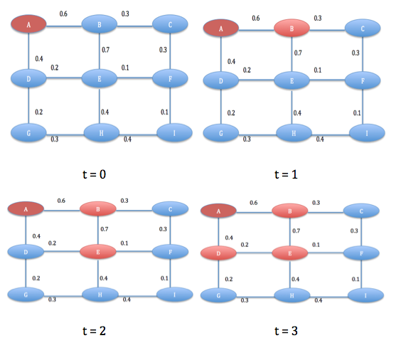

Figure 3

Suppose there is a graph as showed in Figure 3. Each node has the same threshold value, which is ½; the weight of its neighbor is labeled in the edge. At time 0, node A is selected as seed node. At time 1, node A tries to propagate the influence to its neighbors, which are node B and node D. Only nodes B’s active neighbors have a total weight greater than its threshold, node B turns to active state and node D remains inactive. At time 2, the same process follows. Node B propagates its influence to node E. Although, node D fails to switch to active state at time 1, one more its neighbor, i.e. node e turns active state at time 2, which makes the total weight of active neighbor nodes of node D greater than its threshold at time 3. So, at time 3, node D flips from inactive state to active state. After time 3, there is no more node satisfied the condition to flip. The propagation process of influence stops at time 3. Node D reflects the fact in social networks that some people, although, are not likely to accept new technologies, with more and more of their neighbors become active state, they would likely turn to active state.

### Independent Cascade Model

Based on probability theory, IC (Independent Cascade) model is the simplest one, which is investigated by Goldenberg, Libai, and Muller 9. The process of propagation influence in social networks is as followed, at time 0, select an initial seed nodes. If node A becomes active at time t, then it will try to influent its inactive neighbors at time t+1 with probability p getting from system. No matter it successes or not, it will only have this only chance, and cannot try again any more. If an inactive node has more than one newly active node, they will try to influent the inactive node in a random sequence. Yes, the sequence doesn’t matter. If there is no more nodes can be influent, the process stops. The process is shown as Figure 4 and Figure 5.

Figure 4 and Figure 5 have the exactly same graph. And, they both select node A as a seed node. For each newly activated node, it will propagate its influence to its neighbors based on the probabilities of their connection. Each running of the simulation may get a totally different result. Linear Threshold Model and Independent Cascade Model are two classic models in the study of influence propagation in social networks. There are many extended models based on them, below is a model which is very valuable.

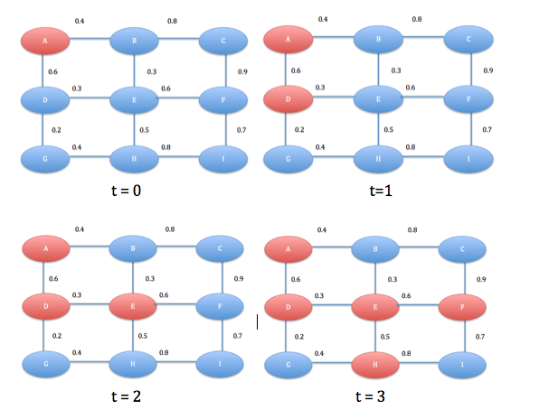

Figure 4

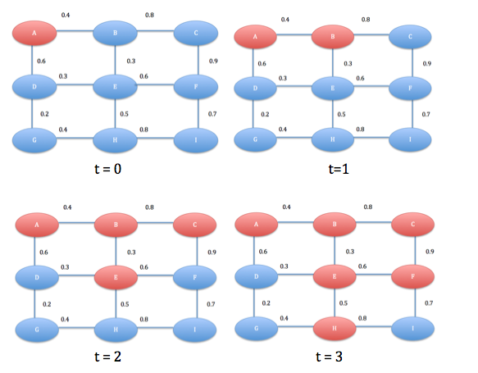

Figure 5

### Extensional IC Model

Linear Threshold (LT) Model and Independent Cascade (IC) Model give us a basic idea of how propagation process works in social networks. However, they are both based on an assumption that whenever a node is affected, it will try to propagate the influence to its neighbors. These two social contagion models formalize the diffusion of information while users’ behaviors are not reflected 10. Wang, Qian, and Lu propose an extensional Independent Cascade (EIC) model by adding a propagation probability to each node in order to distinguish between influence and propagation in social networks.

In 3, their simple greedy algorithm tries to decide whether each edge is valid in advance. They throw a coin with bias pu, w, where u is newly activated node and w is its inactive neighbor. If the trial is success, then the edge is claimed as a live edge; otherwise, it is declared as blocked. In 10, Wang et al. do the similar work. They divide the propagation process into two phases, propagation phase and adoption phase. First, each active node will decide whether or not to propagate the influence with probability ps. If it is success, the active node will try to activate its out-neighbors with related probability of pu, w; Otherwise, all its out edges are blocked. This is a delicate extension to IC model. Considering in disease transmission model, if someone caught a disease, he may not likely spread the virus. Then all his strongly connected people will safe, no one is under danger of catch the disease. If the ill person has strong tendency whatever he gets, all his friends will have to decide whether or not get infection depending on their physical condition. The comparison of classic IC and EIC is as Figure 6 and Figure 7 10.

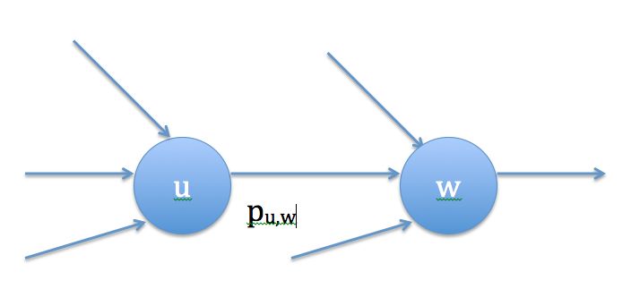

Figure 6

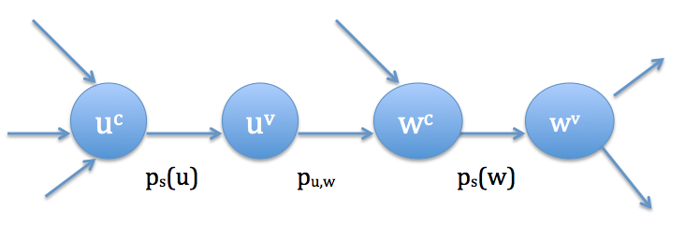

Figure 7

Comparing Figure 6 and Figure 7, in EIC model, they split each node into two nodes. The first nodes has all of its in-neighbors and the second node has all of its out-neighbors. If newly activated node u decides not to propagate the influence, then node u could not affect node w through path uc --> uv --> wc. In my work, I will further extend EIC model.

## Influence Maximization Algorithm

Influence maximization problem is NP-hard in both Linear Threshold Model and Independent Cascade Model, which is proved in 3. They also give the first provable approximation algorithm for the problem.

### Hill-Climbing Algorithm

In 3, they use a greedy hill-climbing algorithm. They prove that the result is a factor of (1- 1/e – ε), which is nearly 63%, in both Linear Threshold Model and Independent Cascade Model. Here e is the natural logarithm base and ε is any small positive real number. They use techniques from theory of submodular functions 11.

### CELF Algorithm

In 3, Kempe et al. prove influence maximization problem is NP-hard, they also give an approximation solution. The biggest drawback of their solution is efficiency. Even picking a small seed set in a moderate large social network, it will take days. In 4, Leskovec et al. try to solve this problem. They propose an algorithm called CELF (Cost-Effective Lazy Forward). By exploiting submodularity property, they greatly reduce the candidate nodes and get an efficient solution, which can scale to large system. Their experiment shows that they will get a near optimal solution while being 700 times faster than the simple greedy algorithm. The effort of trying to reduce the running time of greedy algorithm never stops. In 5, Goyal et al. propose an improved CELF algorithm, which they called CELF++, and this one further decrease the running time 35%-50% comparing to CELF algorithm.

Other people try to solve influence maximization problem from another direction. There are two traditional heuristic methods, degree centrality and distance centrality.

### Heuristic methods

Degree centrality method selects the nodes, which have most connection to social networks. If a node has more neighbors in social network, it is believed to have more influence to social network. This is a good assumption. But in real social networks, high degree nodes tend to connect to each other, which means if we select a second high degree node, which has connection to the first node, to our seed nodes set, it will have litter value in the influence maximization problem in social networks.

Distance centrality method tries to compute the average distance from each node to other nodes in social networks. If a node has relative smaller average distance to all other nodes, it is taken as candidate. But, it needs some work to calculate the average distance for each node, and it may have the same problem as degree centrality method.

Experiments in 3 shows that degree centrality method can get a larger influence spread than other heuristic methods, but is still not as good as greedy algorithm. For the relative low expectation from heuristic methods comparing to greedy algorithm, they are not taken serious in research, until in 6, Chen et al. propose an improved heuristic method on Independent Cascade Model. They get a close result comparing to greedy algorithm, but greatly reduce the running time of picking seed nodes with six orders magnitude. The idea is very simple. Since if a node is selected as seed node, then its neighbor is not as influent to social networks as before. It should discount some degree value. They propose two ways to discount degree of node. One is called SingleDiscount, when one node is selected as seed node, all neighbors of it, which are not in seed nodes set will discount degree by 1. The other way is more complicate. For each newly activate node, it will calculate the affection to its inactive nodes.

# My solution

The study in influence space maximization problem gives a solid foundation to my study in influence speed maximization problem. In order to tackle this problem, there are three main questions need to be solved: First is what is the model to built on? Second is what are the algorithms? And the last one is how to decide the parameters of model. I will solve them one by one.

Inspired by the EIC (Extensional Independent Cascade) Model, I propose new improvement on EIC. EIC divides propagation process into two phases, node A first decides to propagate the influence, and its neighbor then decides to adopt the influence. However, as classic IC model, EIC model also has the same limitation. Newly activated node can only try to propagate the influence to its neighbor once. No matter it successes or not, it will not try to affect its neighbor again. Although this is simple for modeling, it does not reflect the reality in social networks. For example, if your friends posts a message on Facebook “Hey guys, I just got a new IPhone 6!!!!” What is your reaction? Maybe you will not buy a new IPhone the next day. But after several days of consideration, or maybe some other reasons, you make up your decision to purchase one. So, the classics IC and EIC show their drawback in this situation, which can only propagate influence once. I improve EIC model to CDE (Continuous Dynamic Extensional) IC Model. Dynamic is related how to decide probabilities in social networks. I will talk about it later. Continuous solves the drawback in classic IC Model and EIC Model. Instead of propagate influence to its neighbors only once when a node becomes active, it will keep pushing the influence to its neighbors. The process is as Figure 8.  
All edges in Figure 8 have a probability of ½. At time 0, node A is selected as seed node. At time 1, node B gets the influence from node A, and becomes active. At time 2, node B propagates influence to its neighbor node C and node E. At time 3, although node A fails to influent node D at time 0, it gets another opportunity and successes. Node D becomes active, also, node F. The influence process stops at time 3.

The big difference between Continuous IC Model with classic IC Model and EIC model is that, even active node misses its first chance, it can have a second, third chance, until it successes. So, in each step, I would consider not only the newly activated nodes, but also all of the activated nodes, checking inactive neighbors of each active node, trying to propagate the influence with assigned probabilities.

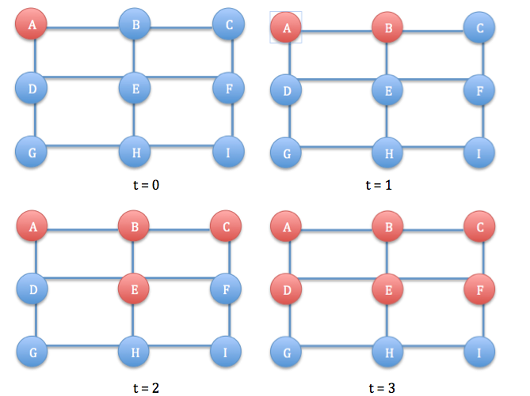

Figure 8

In 6, Chen et al. have shown that properly improved heuristic method can get a matching result with greedy algorithms, and also with several orders magnitude faster. For this reason, I will only try classic heuristic methods and try to improve degree centrality method. Thus I will test four methods in picking seed nodes: Random, Distance-Centered, Degree-Centered and ZeroDiscount. I have talked about Distance-Centered and Degree-Centered methods in previous section. Random method is picking k seed nodes uniformly and randomly from social networks. ZeroDiscount is an improved Degree Centered method inspired by 6. In their paper, they propose a SingleDiscount method, which decrease inactive node degree by one each time one of its neighbors turns to active state. I go further in their direction. If one node is selected as seed node, all of its out-neighbors are useless, since they can all be reached by the newly activated node, also, of the out-neighbors of out-neighbors. So, once a node is picked, I set all of its out-neighbors’ degree to zero.

Like EIC Model, my CDE IC Model also has two phases in its influence propagation, the propagation phase and the adoption phase. There are many ways to decide the probability of each node. The first one is given a random value from [0,1] or a fixed value like ½. This method is easy, however, it does not likely reflect the real social networks. The second method is trying to analyze past record. Like in Twitter, we can analyze all the records between individualities. By the response of different node to the previous events, trying to assign a more precise probability to each edge. This method is well discussed in 12. But, this method is costly and slow, considering the huge logs of a popular social network. I will try a different way. By analyze the character of social networks, giving each edge a reasonable value. Here, I think there are three different kinds of forces that decide whether a node will adopt the influence. I name them as Peer Pressure, Star Effect and Social Trend. Peer Pressure means the influence comes from someone closely connected to you. You are not only meet in social networks, but also strong interaction in daily life. Maybe he is someone you grown up with, or your families. They have strong power to affect you decision. Star Effect means the influence is from some celebrities. They are role model to society and have many followers. You keep updating their activities. But, maybe their life is too far from yours. You may not change you mind easily comparing to the influence from your friends.

# EXPERIMENTS

I will run four methods (Random, Distance-Centered, Degree-Centered and ZeroDiscount) on CDE (Continuous Dynamic Extensional) IC Model. I evaluate the result on two large academic collaboration datasets obtained from arXiv.org. In the first step, I do not consider time constrain on the decision of probabilities, which means I will leave the Dynamic property of Model to later work. So, the model is actually only CE (Continuous Extensional) IC Model, which can be extended to CDE IC Model.

The probability of propagation of each node is decided by the weight of each node. By calculating the total weight of each node’s out-neighbors, I give the node with the highest weight a propagation probability of 1, which means the node will absolutely propagate influence to social network; and, I give the node with the lowest weight a small probability, such as 0.001 or zero. The other nodes’ propagation probabilities can be decided using linear function or the rank of weight in total. In adoption phase, by dividing the edge weight with the sum of all in-neighbors’ weight, I get a value of what is the probability that an inactive node will be influent by its in-neighbor. So, the probability that a node can spread influence to its out-neighbor is the product of the above two probabilities.

Each node can only propagate influence one step in unit time (a second/an hour/a day). Thus an active node can only affect it’s directed out-neighbors in a unit time. By recording how many nodes are affected in each step, we know the speed of influence. Running each method on datasets 100 times, comparing the running time of picking a seed nodes set and influence propagation speed.

## Running time of picking seeds

I use two datasets (hep and phy) from arXiv.org. There are 15233 nodes and 58891 edges in hep dataset, and 37154 nodes and 231584 edges in phy. The running time unit is millisecond.

Table 1

|  |  |  |
| --- | --- | --- |
|  | Hep | Phy |
| Random | 1 | 1 |
| Distance-Centered | 13613 | 186193 |
| Degree-Centered | 45 | 70 |
| ZeroDiscount | 143 | 230 |

From Table 1, we can see that Random method is the fastest, since it does not consider any characters of social networks. The number of nodes and edges doesn’t affect the running time of Random method. Distance-Centered method doesn’t scale well with large dataset. The number of nodes and especially the number of edges greatly affect the running time of this method. Degree-Centered method always has a satisfied running time. It is only related to the number of nodes. ZeroDiscount method is an improvement of Degree-Centered method, it runs a litter slower than Degree-Centered, but is totally acceptable.

I run experiments on both dataset with seed nodes size 20, 50. Each of them will run 40 units time. The total active nodes reflect the average speed over a period. The newly activated nodes in each step reflect the instant speed. The result is as followed.

Figure 9. hep seed=20 total active nodes

Figure 10. hep seed=20 each step active nodes

From Figure 9, we can get all four methods average influence speed. Random method has the worst performance as expected. Degree-Centered is the previous existing best heuristic method. It is about 20% faster than Distance-Centered method. Although we lost a tiny time in picking seed nodes with ZeroDiscount method comparing to Degree-Centered method, we get about 10% faster average spread speed than the already existing best heuristic method.

From Figure 10, we can see that during the propagation process, there is no much difference in speed of each step between Degree-Centered and Distance-Centered. The initial high degree nodes cause the difference in average speed. As Degree-Centered method, ZeroDiscount method also has a spike at the first step. And, it can almost beats Degree-Centered in each step.

Figure 11. hep seed=50 total active nodes

The trend in Figure 11 is similar to Figure 10. However, the average speed of ZeroDiscount method is about 20% faster than Degree-Centered, much better than when seed nodes size is 20. This is because that when we choose more seed nodes, the drawback of Degree-Centered becoming more obvious.

Figure 12. hep seed=50 each step active nodes

Figure 12 is similar to Figure 10. And, it is more obvious that ZeroDiscount method always beats other heuristic methods.

I don’t show to result over phy dataset, it is similar to hep dataset.

# CONCLUSION

I extend the EIC (Extensional Independent Cascade) Model to CE (Continuous Extensional) IC Model to overcome the drawback that an active node can only try to propagate its influence to its neighbors once. In my model, the active node will continuously try to affect its neighbors, which is more close to real social networks. Later, I will extend CE IC Model to CDE (Continuous Dynamic Extensional) IC Model, which will includes time constrain to make adoption probability of node change with time.

I run four algorithms on my model, Random, Distance-Centered, Degree-Centered and ZeroDiscount method. Degree-Centered method is the most famous heuristic method and has the best result before. And, my experiment shows that my ZeroDiscount method can beat Degree-Centered method about 10%-20%. Both in average speed and instant speed of influence propagation.

I distinguish the influence source of node. I call them Peer Pressure and Star Effect. And, give them different propagation probability.

# FUTURE WORK

I run my experiments on two datasets. Maybe I can try my solution to more datasets. The dynamic property of model will be added in the next step. Some factor that may affect the adoption probability coming from the whole social networks, which I called Global Trend, will also be considered in the future work.

# Reference

**1.** Domingos P, Richardson M. Mining the network value of customers. *Proceedings of the seventh ACM SIGKDD international conference on Knowledge discovery and data mining*. San Francisco, California: ACM; 2001:57-66.

**2.** Richardson M, Domingos P. Mining knowledge-sharing sites for viral marketing. *Proceedings of the eighth ACM SIGKDD international conference on Knowledge discovery and data mining*. Edmonton, Alberta, Canada: ACM; 2002:61-70.

**3.** Kempe D, Kleinberg J, #201, Tardos v. Maximizing the spread of influence through a social network. *Proceedings of the ninth ACM SIGKDD international conference on Knowledge discovery and data mining*. Washington, D.C.: ACM; 2003:137-146.

**4.** Leskovec J, Krause A, Guestrin C, Faloutsos C, VanBriesen J, Glance N. Cost-effective outbreak detection in networks. *Proceedings of the 13th ACM SIGKDD international conference on Knowledge discovery and data mining*. San Jose, California, USA: ACM; 2007:420-429.

**5.** Goyal A, Lu W, Lakshmanan LVS. CELF++: optimizing the greedy algorithm for influence maximization in social networks. *Proceedings of the 20th international conference companion on World wide web*. Hyderabad, India: ACM; 2011:47-48.

**6.** Chen W, Wang Y, Yang S. Efficient influence maximization in social networks. *Proceedings of the 15th ACM SIGKDD international conference on Knowledge discovery and data mining*. Paris, France: ACM; 2009:199-208.

**7.** Granovetter M. Threshold Models of Collective Behavior. *The American Journal of Sociology.* May, 1978 1978;83(6):23.

**8.** Schelling TC. Miromotives and Macrobehavior. 1978.

**9.** Jacob Goldenberg BL, Eitan Muller. Talk of the Network: A Complex Systems Look at the Underlying Process of Word-of-Mouth. *Marketing Letters.* 2001;12(3):12.

**10.** Wang Z, Qian Z, Lu S. A probability based algorithm for influence maximization in social networks. *Proceedings of the 5th Asia-Pacific Symposium on Internetware*. Changsha, China: ACM; 2013:1-7.

**11.** Gerard Cornuejols aLF, George L Nemhauser. Location of Bank Accounts to Optimize Float: An Analytic Study of Exact and Approximate Algorithms. *Management Science.* 1977;23(8):21.

**12.** Goyal A, Bonchi F, Lakshmanan LVS. Learning influence probabilities in social networks. *Proceedings of the third ACM international conference on Web search and data mining*. New York, New York, USA: ACM; 2010:241-250.